BACSE101 Problem Solving using Python

PROJECT REPORT
on

VIT University Portal
Prepared by

Harshit Borade – 25BCE0609 SHILAJIT Banerjee – 25BCE0569
Shourya Singh – 25BCE0615

Under the supervision of
Prof. Sripriyanka G


School of Computer Science and Engineering Vellore Institute of Technology, Vellore.

November 04, 2025

Table of Contents
Abstract
- Introduction
- Problem Statement and Objectives
- Implementation Code
- Demo Screenshots
- Conclusion

Abstract

This project presents a "VIT University Portal," a role-based desktop GUI application developed in Python. The system addresses the need for a centralized management portal within an academic institution. Built using tkinter and the ttkbootstrap library for a modern user interface, the application provides three distinct user dashboards: Student, Faculty, and Admin. Students can log in to view their timetable, check exam schedules, and monitor course-specific progress, including marks, attendance, and project deadlines. Faculty members can manage their assigned courses, update student attendance, add marks, and assign new projects to all enrolled students. The Admin dashboard provides comprehensive user management, including the ability to add new users (students or faculty), delete existing users, and reset passwords. All application data is decoupled from the UI, managed by a dedicated Data Manager class, and persisted in JSON files for credentials, student data, and course information. This design ensures a clean separation of concerns and provides a functional prototype for a university-wide management system.

Introduction
This project is a comprehensive desktop application designed to simulate a university management portal. The core of the application is a multi-layered architecture that separates the user interface from the data logic.
The application is built around three main components:
- main.py : The main entry point that initializes the data paths and launches the application.
- data_manager.py : The "model" or backend of the application. This class is solely responsible for loading, processing, and saving all data to and from JSON files. It handles all business logic, such as validating a login, adding a new user, or calculating grades, ensuring the GUI remains clean.
- gui.py : The "view" and "controller" of the application. It uses tkinter and ttkbootstrap to create all the windows, frames, and widgets. It takes user input, passes it to the Data Manager for processing, and then displays the results

Domain Information
- The project operates in the Educational Technology (EdTech) and Academic Administration domain. It simulates a small-scale University Portal, often called a Student Information System (SIS), providing specific, role-based functionalities to the primary stakeholders of a university.

Software Libraries Used
  - tkinter (and ttk): The standard Python library for creating the core GUI windows, frames, and widgets.
  - ttkbootstrap: A modern theme extension for tkinter used to provide a professional, themed appearance (e.g., the 'cosmo' theme, and bootstyle buttons like 'primary', 'danger', 'info').
  - json: A built-in Python library used to serialize and deserialize data for persistent storage in
.json files .
  - os: A built-in library used to check for the existence of the data directory and create it if necessary, ensuring file paths are valid.

Contributions by Team Members
- SHILAJIT Banerjee: e.g., Designed and implemented the front-end GUI (gui.py), including all frames, widgets, and user-facing logic.
  - Harshit Borade: e.g., Developed the back-end data logic (data_manager.py), including JSON file handling and all data manipulation methods.
  - Shourya Singh: e.g., Integrated the front-end and back-end, managed testing, and debugged the application flow.

Challenges Faced
  - Multi-Page GUI Management: A key challenge was creating a multi-page dashboard within a single tkinter window. This was solved by using a main container frame and a show_frame() method. This method raises the desired frame (e.g., LoginFrame, StudentFrame) to the top, creating the illusion of switching pages .

  - Role-Based State: Managing the application's state (i.e., "who is logged in and what is their role?") was critical. This was solved in the main App class by storing the current_user and current_role upon a successful login. This "controller" instance was then passed to all frames, giving them access to the current user's identity and permissions.

  - Dynamic UI Forms: The Admin's "Add User" form needed to change dynamically: if the 'faculty' role was selected, a list of courses should appear for assignment. This was achieved by creating a separate frame for the course checkboxes and using the .grid() and .grid_forget() methods to show or hide this frame based on the role dropdown's selection.

Problem Statement and Objectives
Academic institutions require a centralized and efficient system to manage information for different user groups. A lack of such a system leads to data being scattered, administrative inefficiency, and a disconnected experience for students and faculty. Students struggle to find their academic information, faculty lack simple tools to manage their courses, and administrators spend excessive time on basic user management.

Objectives
- To develop a secure, role-based desktop GUI application using Python and tkinter.
- To implement three distinct user dashboards for Student, Faculty, and Admin roles, accessible via a single login page.
- To provide a Student Dashboard where students can view their hard-coded timetable, check dynamic exam schedules, and review course-specific attendance, marks, and project deadlines.
- To provide a Faculty Dashboard with tools to manage assigned courses, including forms to add/update student marks, set student attendance, assign new project deadlines to an entire course, and add new exams to the global schedule.
- To provide an Admin Dashboard for user lifecycle management, including adding new students or faculty, deleting any user, and resetting user passwords.
- To ensure a separation of concerns by creating a Data Manager class to handle all data persistence using JSON files, keeping the GUI code clean of data logic .

Implementation

Feature: Role-Based Login and Frame Switching

This code from the main App class in gui.py handles the login logic. It validates credentials using the data_manager and then calls show_frame to display the correct dashboard based on the user's role
# app/gui.py

def show_frame(self, FrameClass): """Raises a frame to the top."""
# Destroy old role-specific frames on logout if FrameClass == LoginFrame:
for F in self.frames.values():
if F. class != LoginFrame: F.destroy()
self.frames = {} self.current_user = None self.current_role = None

if FrameClass not in self.frames:
self.frames[FrameClass] = FrameClass(self.container, self)

frame = self.frames[FrameClass] frame.grid(row=0, column=0, sticky="nsew")
# Call 'on_show' method if it exists, to refresh data if hasattr(frame, "on_show"):
frame.on_show() frame.tkraise()
def attempt_login(self, role, user, password):
if self.data_manager.validate_login(role, user, password): self.current_user = user
self.current_role = role if role == 'student':
self.show_frame(StudentFrame) elif role == 'faculty':
self.show_frame(FacultyFrame) elif role == 'admin':
self.show_frame(AdminFrame) return True
else:
messagebox.showerror("Login Failed", "Invalid username or password.") return False
, any important code snippet, etc here.

Feature: Student Dashboard (Viewing Data)
This method from StudentFrame in gui.py shows how data is fetched from the data_manager and displayed in ttk.Treeview widgets for the student.

# app/gui.py

def show_course_dashboard(self, course_id): self.clear_content_pane()
dm = self.controller.data_manager student_id = self.controller.current_user
course_name = self.student_courses.get(course_id, course_id)

tkb.Label(self.content_pane, text=f"{course_name} ({course_id})", font=("Arial", 16, "bold")).pack(anchor='w')

# --- Attendance ---
tkb.Label(self.content_pane, text="Attendance", font=("Arial", 14, "bold"), bootstyle="primary").pack(anchor='w', pady=(20, 5))
att = dm.get_attendance(student_id, course_id)
att_text = "No attendance recorded." if att is None else f"Your Attendance is:
{att}%"
tkb.Label(self.content_pane, text=att_text, font=("Arial", 12)).pack(anchor='w')

# --- Marks ---
tkb.Label(self.content_pane, text="Marks", font=("Arial", 14, "bold"), bootstyle="primary").pack(anchor='w', pady=(20, 5))
cols = ('Exam', 'Mark')
tv_marks = tkb.Treeview(self.content_pane, columns=cols, show='headings', height=4, bootstyle="info")
for c in cols: tv_marks.heading(c, text=c)

marks = dm.get_marks(student_id, course_id) if not marks:
tv_marks.insert('', 'end', values=("No marks available yet.", "")) else:
for subj, mark in marks.items(): tv_marks.insert('', 'end', values=(subj, mark))
tv_marks.pack(fill='x', pady=5)

Feature: Faculty Dashboard (Data Entry Form)
This method from FacultyFrame in gui.py builds the "Add Marks" tab. It creates a form with a student dropdown, entry fields, and a submit button that calls the data_manager to save the new mark.

# app/gui.py

def populate_marks_tab(self, parent, course_id):
tkb.Label(parent, text="Select Student:", width=15).pack(anchor='w') student_var, students = self._create_student_dropdown(parent, course_id) if not students: return

tkb.Label(parent, text="Assessment Name:", width=30).pack(anchor='w', pady=(10,0))
subject_entry = tkb.Entry(parent, width=40) subject_entry.pack(fill='x', pady=5, padx=5)

tkb.Label(parent, text="Mark:", width=20).pack(anchor='w', pady=(10,0)) vcmd = (parent.register(self.validate_percent), '%P')
mark_entry = tkb.Entry(parent, width=40, validate='key', validatecommand=vcmd)
mark_entry.pack(fill='x', pady=5, padx=5)

status_label = tkb.Label(parent, text="", font=("Arial", 10)) status_label.pack(pady=10)

def on_submit():
student = student_var.get() subject = subject_entry.get() mark = mark_entry.get()
if student == "Select Student":
status_label.config(text="Please select a student.", foreground="red") return

success, message = self.controller.data_manager.add_student_mark(student, course_id, subject, mark)
if success:
status_label.config(text=message, foreground="green") # ... (clear entries)
else:
status_label.config(text=message, foreground="red")
tkb.Button(parent, text="Submit", command=on_submit, bootstyle="success").pack(pady=10, ipadx=10)

Feature: Data Persistence (Data Manager)
This method from data_manager.py shows the business logic for adding a new user. It checks for duplicates, updates the self.credentials dictionary, and (if a student) also updates the self.student_data dictionary. Finally, it calls the _save_... methods to write the changes to the JSON files.

# app/data_manager.py

def add_user(self, role, user_id, password, courses=None): # Added courses=None if not user_id or not password:
return False, "User ID and password cannot be empty." user_id = user_id.strip()
# Check for existing user in any role for r in self.credentials:
if user_id in self.credentials[r]:
return False, f"User ID '{user_id}' already exists in the {r} role."

if role == 'student':
# 1. Assign ALL courses to the new student all_course_ids = self.get_all_course_ids()

self.credentials['student'][user_id] = password self.student_data['students'][user_id] = {
"enrolled_courses": all_course_ids, # Enroll in all courses "course_data": {}
}
# ... (initialize course data) ... self._save_credentials() self._save_student_data()
return True, f"Student '{user_id}' added successfully..."

elif role == 'faculty': self.credentials['faculty'][user_id] = password

# 2. Assign selected courses to the faculty member assigned_courses = []
if courses:
for course_id in courses:
if course_id in self.courses:
# Update the course data to assign the faculty member self.courses[course_id]['faculty'] = user_id assigned_courses.append(course_id)
self._save_courses()

self._save_credentials()
return True, f"Faculty '{user_id}' added successfully..."

Demo Screenshots

Login Page:
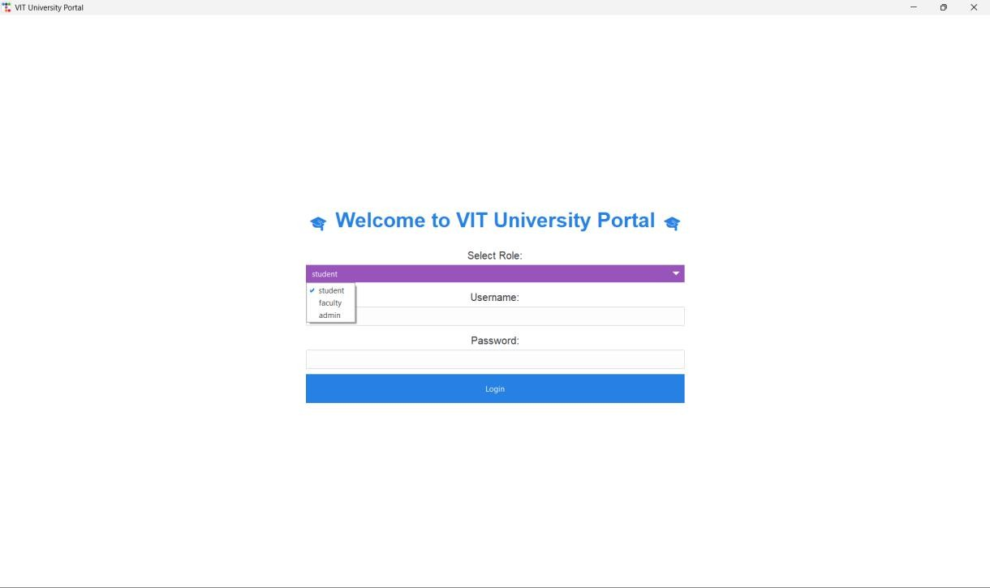

Student Dashboard:
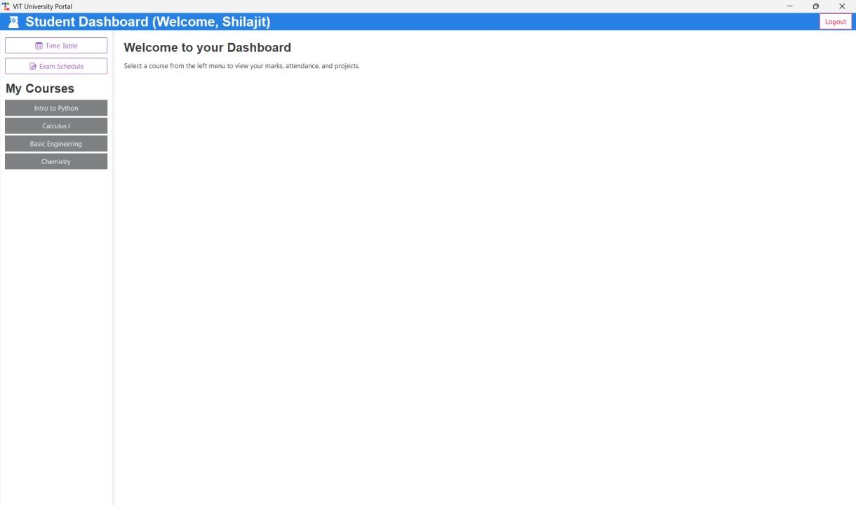

Student Course Details:
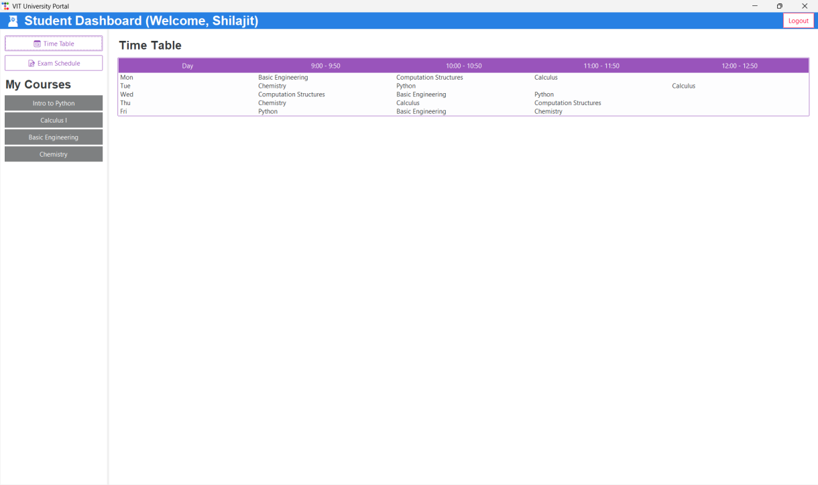
Student Exam Schedule
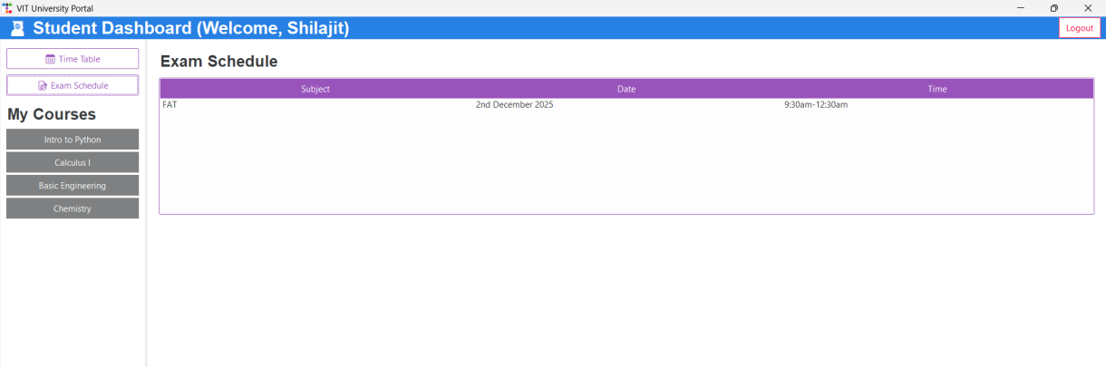

Faculty Dashboard:
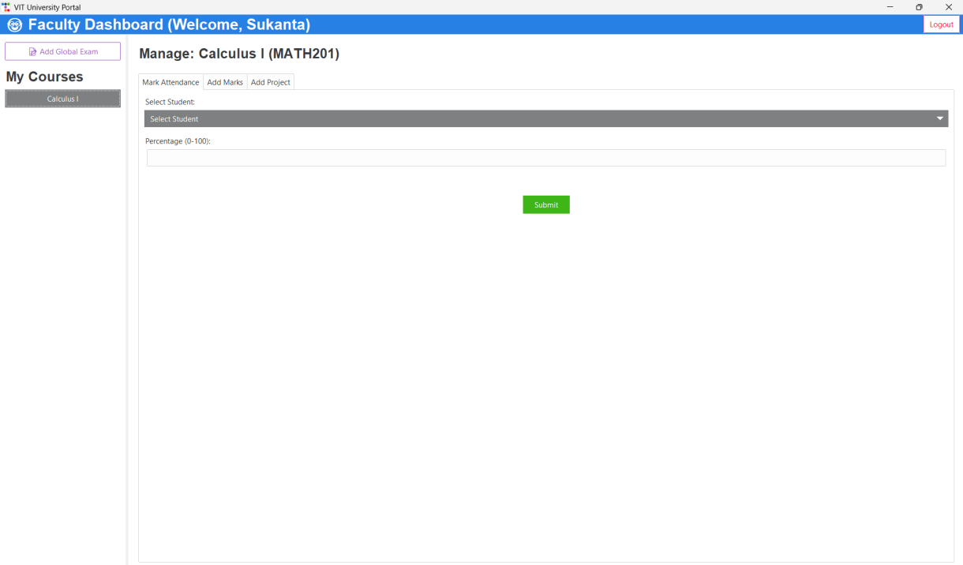
Admin Dashboard:
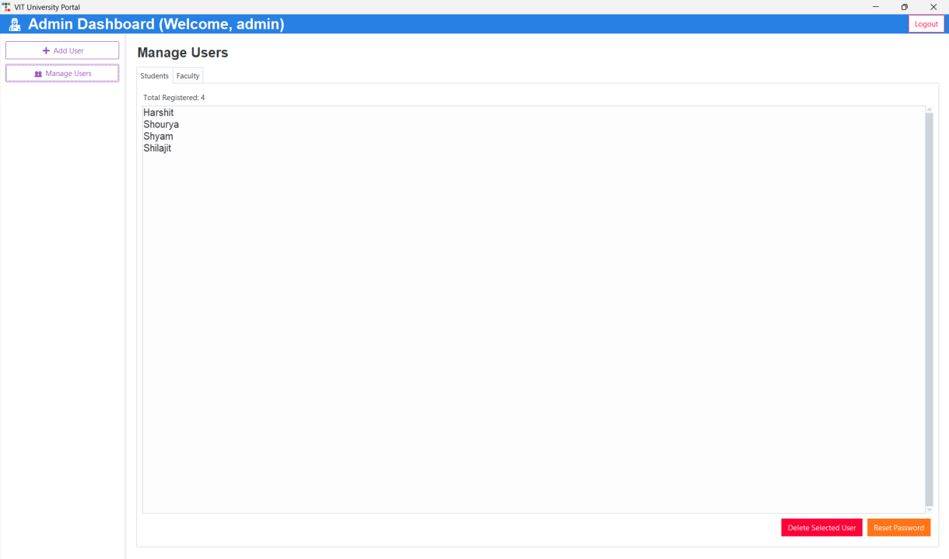

Conclusion

The "VIT University Portal" project successfully achieves its objectives by delivering a functional, multi-role desktop application. The system correctly implements three distinct dashboards for Students, Faculty, and Administrators, each with features tailored to their role. The architectural decision to separate the data logic (Data Manager) from the user interface (gui.py) proved highly effective, resulting in code that is cleaner, easier to debug, and more maintainable. The use of the ttkbootstrap library significantly enhanced the tkinter UI, providing a modern and professional user experience.

Future Scope
While the project is a successful prototype, it can be expanded in several key areas:
- Database Migration: The most significant improvement would be to migrate data storage from JSON files to a robust SQL database like SQLite (for portability) or PostgreSQL (for scalability). This would provide better performance, data integrity, and allow for more complex queries.
- Dynamic Timetable: The student timetable is currently hard-coded in the GUI. A future version should make this dynamic, loading it from the Data Manager so it can be unique for each student and managed by faculty or admins.

- Enhanced Features: The application could be expanded with more features, such as a course registration system for students, a gradebook and charting module for faculty, and a system-wide announcements module for admins.
- Packaging: The application could be packaged into a standalone executable file (using tools like PyInstaller or cx_Freeze) to allow users to run it without installing Python or any libraries.

